KMC HACKATHON 1.0 PROJECT REPORT
Project title: Study Mitra

Team Name: Beyond-Bits.
Team Members:
1. Sabal Bajagain – Lead Developer and Problem Statement
2.Samyam Aryal – Lead Reporter and Presenter, Assistant in Designing
3. Rythum Kadel – Lead Designer, Technical Support
4. Prasanga Ghimire – Lead Inspector, Solution Statement

1. Abstract
Study Mitra is a web-based study platform made for students to study together in a focused and productive way. Unlike common video meeting apps, Study Mitra is specially designed for studying. It allows students to create small study rooms with a maximum of 5 members so that everyone stays attentive. One of the main features of Study Mitra is the use of AI (Groq Llama), which helps students generate notes and understand topics instantly. The platform also includes a profile and portfolio feature where students can save their notes and achievements. Study Mitra is built using Django, SQL, and modern web technologies.
2. Problem Statement
Students today face many problems while studying online:
• They lose focus because most platforms are crowded or distracting.
• They need to switch between many apps for video calls, notes, and AI help.
• They do not have a proper place to show their study progress or projects.
3. Existing System
Currently, students use different platforms for different purposes:
• Study Together / Focusmate for study rooms.
• Zoom / Google Meet for video calls.
• ChatGPT for AI help.
• LinkedIn for portfolios.
These platforms are not connected, which makes studying less efficient.
4. Proposed Solution
Study Mitra combines all study needs into one platform:
• Small study rooms with only 5 users.
• Built-in AI assistant for notes and explanations.
• Real-time chat for discussion.
• User profile and portfolio to save achievements.
5. Objectives
• To create focused study rooms with limited users.
• To integrate AI for instant note generation.
• To allow users to save notes digitally.
• To help students build a study portfolio.
• To design a simple and user-friendly interface.
6. Technology Used
Backend: Python (Django)
Frontend: HTML, CSS, JavaScript
Database: PostgreSQL, Firebase
AI Model: Groq Llama
Real-time Chat: Firebase
Image Storage: Cloudinary
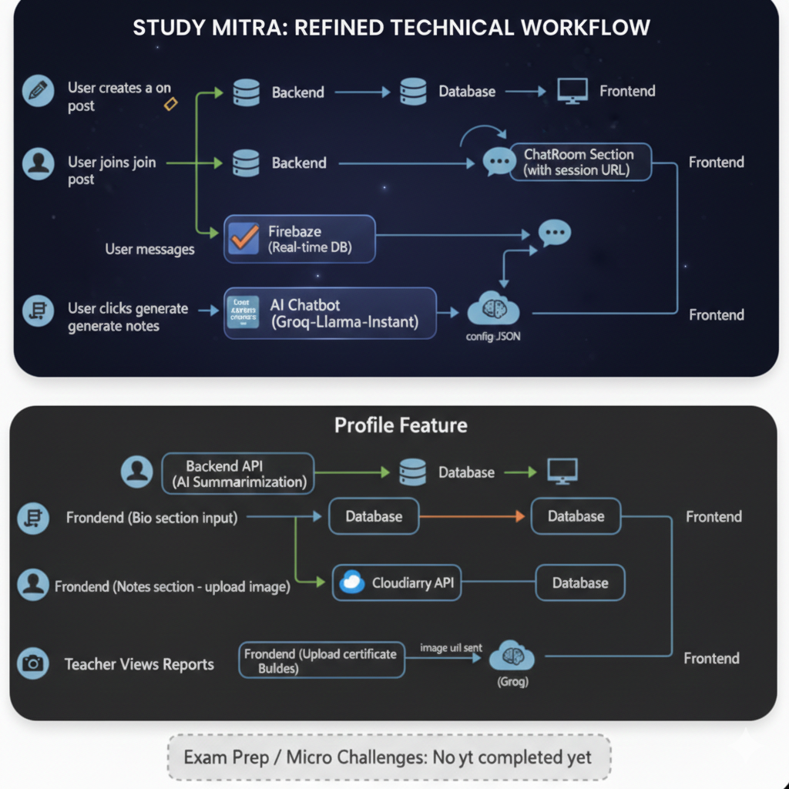
7. System Workflow (Based on Diagram)
Study Along Feature:
1. User creates a study post from the frontend.
2. The request goes to the backend and is saved in the database.
3. Other users click ‘Join’ and the backend fetches session data.
4. Users enter a chat room using a session URL.
5. Messages are handled in real time using Firebase.
6. When a user clicks ‘Generate Notes’, the AI model (Groq Llama) processes the request.
7. The AI-generated notes are sent back to the frontend and can be saved.
Profile Feature:
1. User enters bio details from the frontend.
2. Data is stored in the database.
3. Notes images and certificates are uploaded using Cloudinary.
4. Uploaded data is saved and shown in the user profile.
8. System Wireframe Description
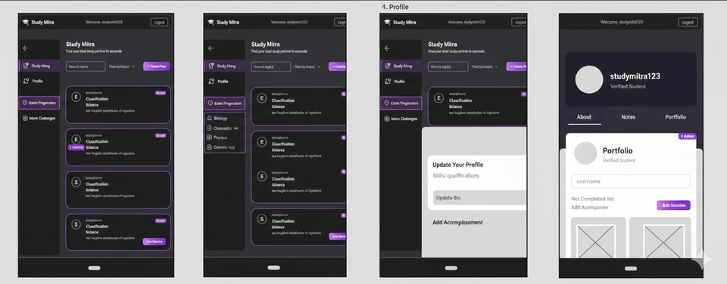
• Landing Page: Shows Study Mitra name and options to start studying.
• Dashboard: Displays study rooms, subjects, and navigation menu.
• Study Room: Shows up to 5 users, chat section, timer, and AI notes option.
• Profile Page: Shows user bio, saved notes, and portfolio section.
This wireframe helps understand how users move through the system.
9. Results
• Study rooms successfully limit users to 5.
• AI generates notes quickly.
• Users can save notes easily.
• Profiles display achievements properly.
10. Advantages
• Better focus due to small group size.
• Fast AI responses.
• All study tools in one place.
• Helps students build a digital portfolio.
11. Limitations
• Not suitable for large classes.
• Needs stable internet.
• AI may sometimes give incorrect answers.
12. Future Improvements
• Mobile app for Android and iOS.
• Online whiteboard feature.
• Pomodoro timer for better time management.
• More AI models for different subjects.
13. Conclusion
Study Mitra is a modern study platform that helps students study together effectively. By combining study rooms, AI assistance, and portfolio building, it provides a complete solution for students. The system is simple, fast, and useful for academic growth.

